Create a sample dataset and implement the below Pig commands on the same dataset.

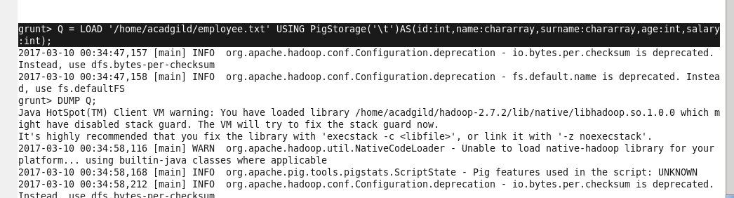

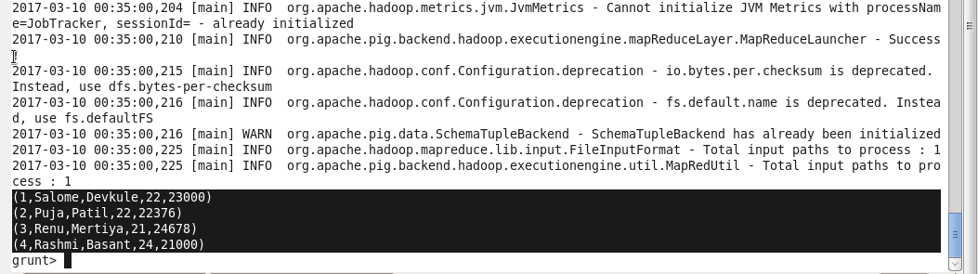1) Concat 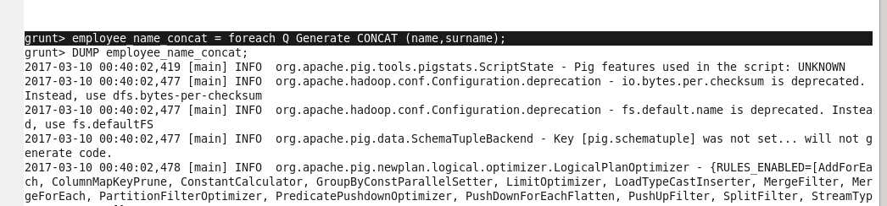

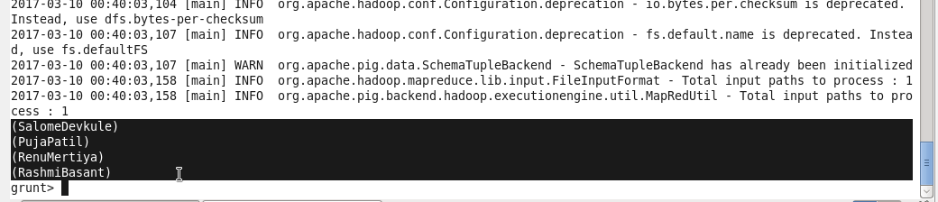

2) Tokenize

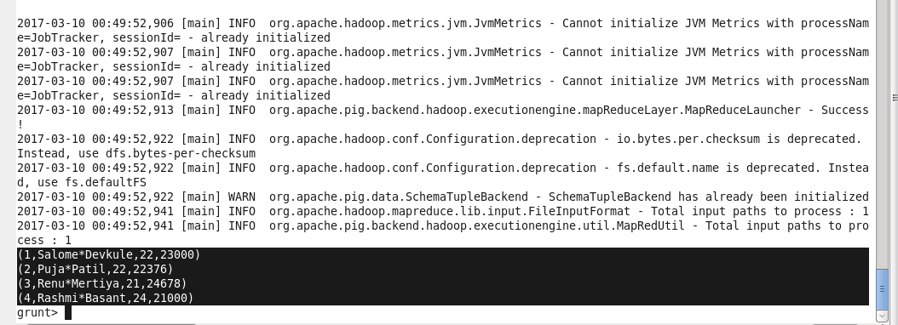

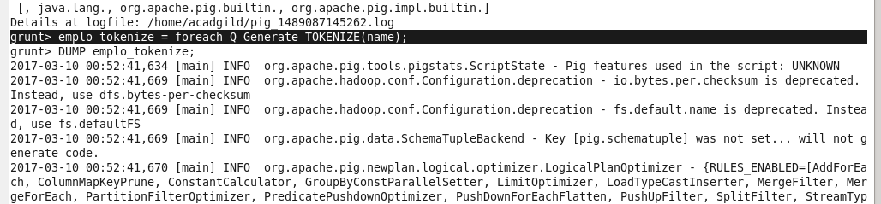

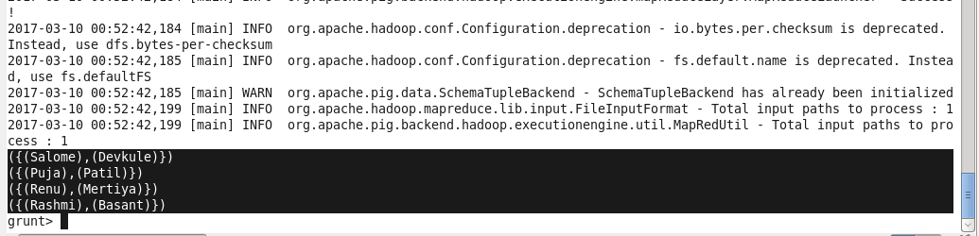

3) Sum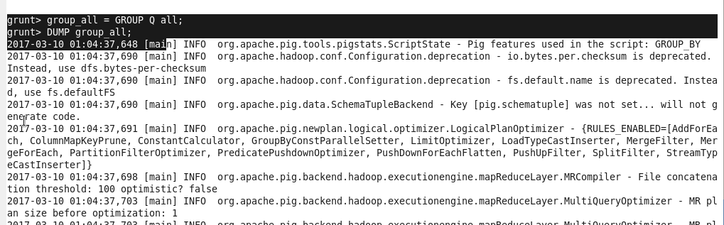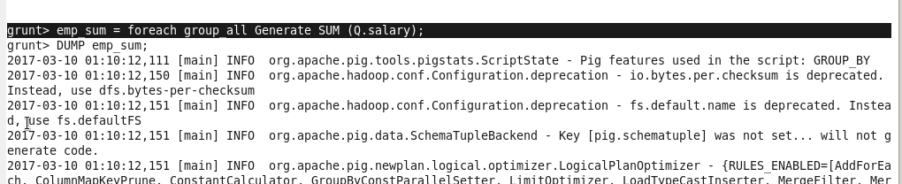

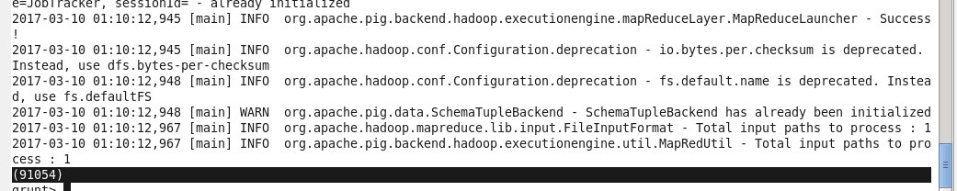

4) Min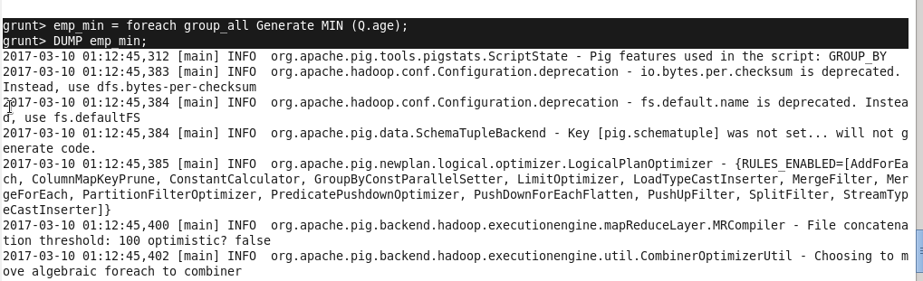

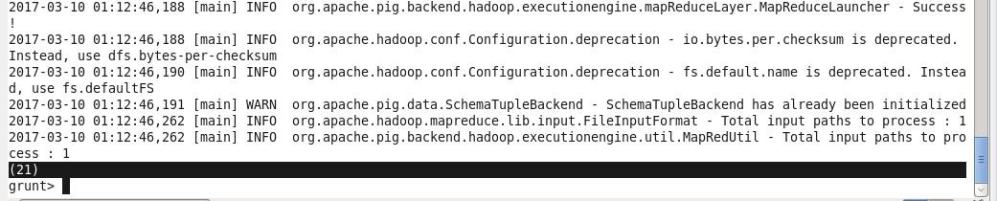5) Max 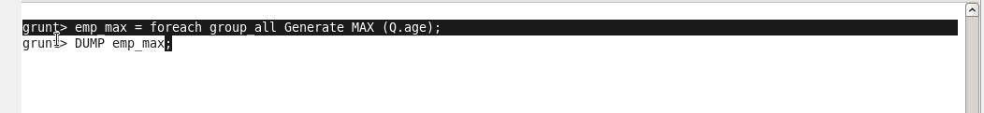

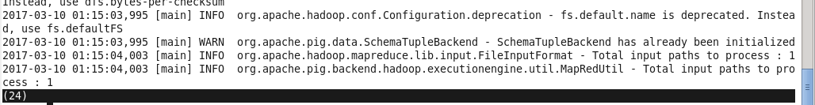

6) Limit

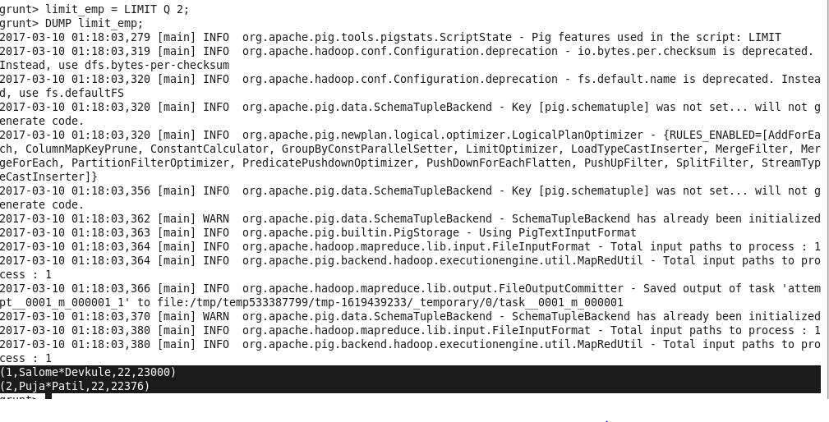 7) Store

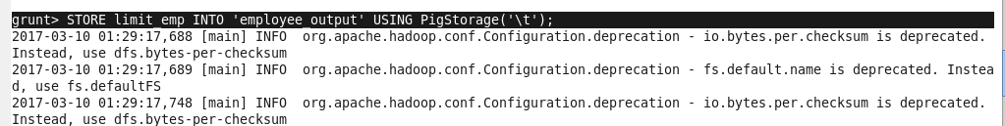

C:\Users\612909\Desktop\hadoop\assign10.2storeoutput.PNG

8) Distinct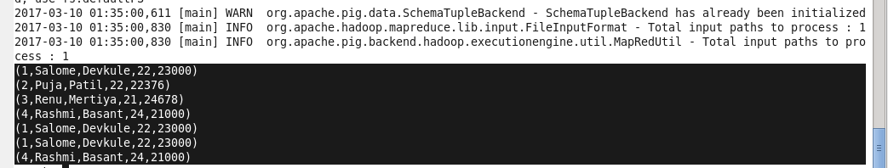

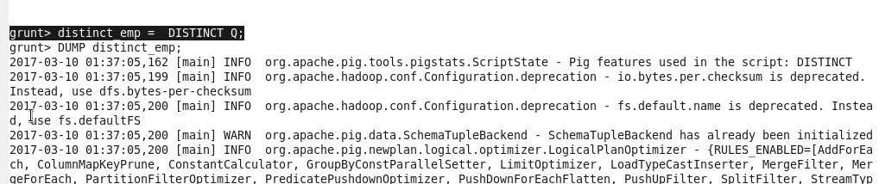

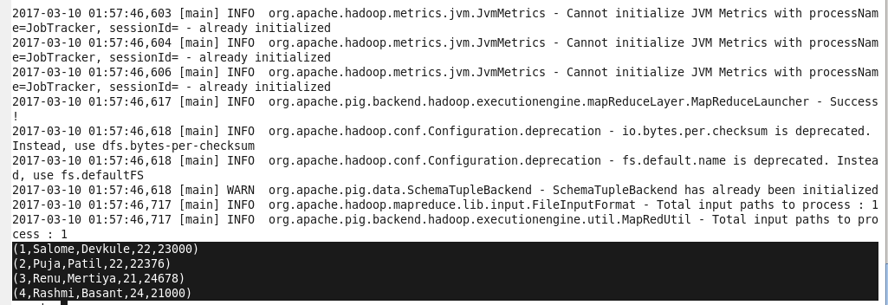

9) Flatten